VS2013 编译运行 OTL 示例代码
- 把otlv.h添加进来
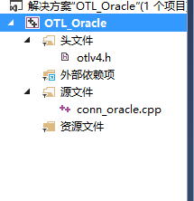
2、右键项目->属性->C/C++ ->常规-> 附加包含目录，输入以下内容
C:\software\Oracle11g\product\11.2.0\dbhome_1\OCI\include
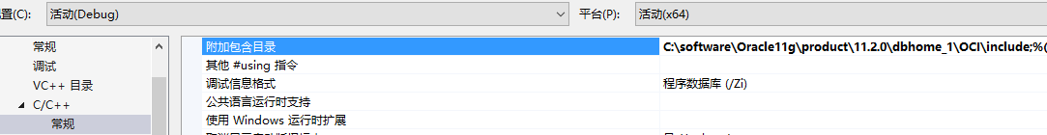

3、右键项目->属性->链接器 ->常规-> 附加库目录，输入以下内容
C:\software\Oracle11g\product\11.2.0\dbhome_1\OCI\lib\MSVC
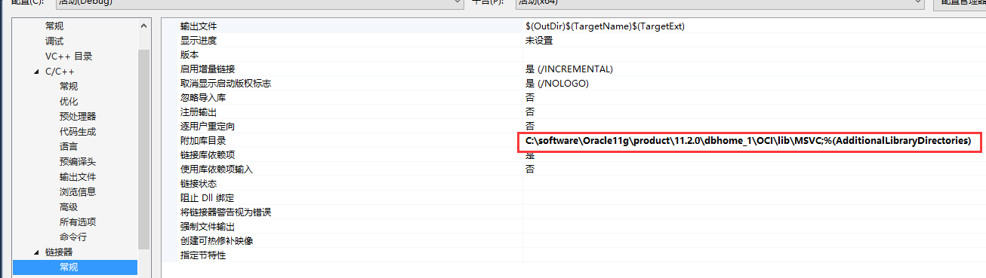

4、右键项目->属性->链接器 ->输入-> 附加依赖项，输入以下内容
oci.lib

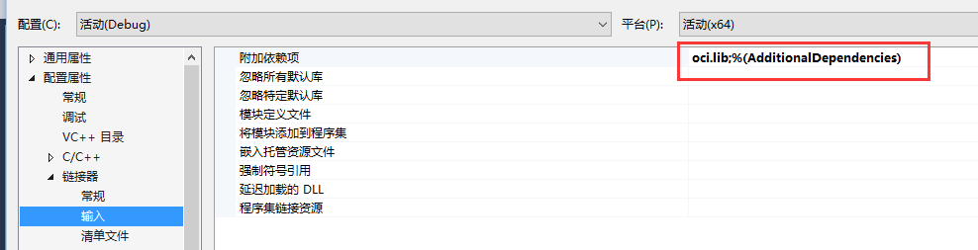
5、注意选择x64进行编译
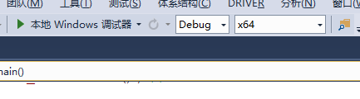
6、测试代码
#include <iostream>
using namespace std;

#include <stdio.h>
#include <stdlib.h>
#define OTL_ORA8I // Compile OTL 4.0/OCI8i
#define OTL_UNICODE // Enable Unicode OTL for OCI8i
#include "otlv4.h" // include the OTL 4.0 header file

otl_connect db; // connect object

void insert()
// insert rows into table
{
otl_stream o(50, // buffer size
"insert into test_tab values(:f1<float>,:f2<char[31]>)",
// SQL statement
db // connect object
);
char tmp[32];
unsigned short tmp2[32]; // Null terminated Unicode character array.

for (int i = 1; i <= 100; ++i){
sprintf_s(tmp, "Name%d", i);
unsigned short* c2 = tmp2;
char* c1 = tmp;
// Unicode's first 128 characters are ASCII (0..127), so
// all is needed for converting ASCII into Unicode is as follows:
while (*c1){
*c2 = (unsigned char)*c1;
++c1; ++c2;
}
*c2 = 0; // target Unicode string is null terminated,
// only the null terminator is a two-byte character,
// not one-byte
o << (float)i;
o << (unsigned char*)tmp2;
// overloaded operator<<(const unsigned char*) in the case of Unicode
// OTL accepts a pointer to a Unicode character array.
// operator<<(const unsigned short*) wasn't overloaded
// in order to avoid ambiguity in C++ type casting.
}

}

void select()
{
otl_stream i(1, // buffer size
"begin "
" open :cur<refcur,out[50]> for "
// :cur is a bind variable name, refcur -- its type,
// out -- output parameter, 50 -- the buffer size when this
// reference cursor will be attached to otl_refcur_stream
" select * "
" from test_tab "
" where f1>=:f<int,in> and f1<=:f*2; "
"end;", // PL/SQL block returns a referenced cursor
db // connect object
);
// create select stream with referenced cursor

i.set_commit(0); // set stream "auto-commit" to OFF.

float f1;
unsigned short f2[32];

otl_refcur_stream s; // reference cursor stream for reading rows.

i << 8; // assigning :f = 8
i >> s; // initializing the refrence cursor stream with the output
// reference cursor.

while (!s.eof()){ // while not end-of-data
s >> f1;
s >> (unsigned char*)f2;
// overloaded operator>>(unsigned char*) in the case of Unicode
// OTL accepts a pointer to a Unicode chracter array.
// operator>>(unsigned short*) wasn't overloaded
// in order to avoid ambiguity in C++ type casting.
cout << "f1=" << f1 << ", f2=";
// Unicode's first 128 characters are ASCII, so in order
// to convert Unicode back to ASCII all is needed is
// as follows:
for (int j = 0; f2[j] != 0; ++j){
cout << (char)f2[j];
}
cout << endl;
}

s.close(); // closing the reference cursor

i << 4; // assigning :f = 4
i >> s;

while (!s.eof()){ // while not end-of-data
s >> f1;
s >> (unsigned char*)f2;
// overloaded operator>>(unsigned char*) in the case of Unicode
// OTL accepts a pointer to a Unicode chracter array.
// operator>>(unsigned short*) wasn't overloaded
// in order to avoid ambiguity in C++ type casting.
cout << "f1=" << f1 << ", f2=";
// Unicode's first 128 characters are ASCII, so in order
// to convert Unicode back to ASCII all is needed is
// as follows:
for (int j = 0; f2[j] != 0; ++j){
cout << (char)f2[j];
}
cout << endl;
}

// there is no need to explicitly calls s.close() since s's destructor
// will take care of closing the stream
}

int main()
{
otl_connect::otl_initialize(); // initialize OCI environment
try{

db.rlogon("scott/tiger@192.168.1.40:1521/orcl"); // connect to Oracle

otl_cursor::direct_exec
(
db,
"drop table test_tab",
otl_exception::disabled // disable OTL exceptions
); // drop table

otl_cursor::direct_exec
(
db,
"create table test_tab(f1 number, f2 nvarchar2(60))"
); // create table

db.set_character_set(SQLCS_NCHAR);

insert(); // insert records into table
select(); // select records from table

}

catch (otl_exception& p){ // intercept OTL exceptions
cerr << p.msg << endl; // print out error message
cerr << p.stm_text << endl; // print out SQL that caused the error
cerr << p.var_info << endl; // print out the variable that caused the error
}

db.logoff(); // disconnect from Oracle
system("pause");
return 0;

}

